Galway County Council
Tuam Town Water Distribution

Contractor : Coffey Construction (I) Ltd.
Consulting Engineers : Ryan Hanley
Director of Services : Jim Cullen

Investing in your future

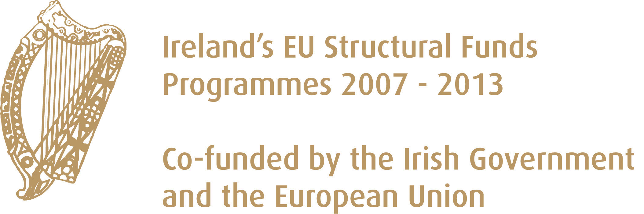

Summary

The Water Services contract in Tuam was the largest single Civils contract ever undertaken by the Water Services Section of Galway County Council. Water Conservation was a major element of this project accounting for approximately 23% of the final certified account. The Water Conservation element consisted of replacing approximately 30km of watermains and the major project milestones are as follows :

Description | Date
Tenders advertised | 30 August, 2007
Closing date for tenders | 26 October, 2007
Report on Tenders submitted to Department | 17 July, 2008
Department approval to tenders | 30 October, 2008
Contract signed | 29 January, 2010
Commencement Date | 15 March, 2010
Certificate of Substantial Completion | 15 June, 2012
Maintenance Certificate | 16 August, 2013

The success of the project in relation to water conservation cannot be disputed with the levels of UFW in Tuam falling from 52% in 2008 to 32.35% in October 2015. That represents an improvement of 38% which has many benefits both in terms of input costs saved, and capital expenditure deferred and it also leaves Tuam secure in terms of water services capacity to attract future industry and population expansion.

Funding

The project was funded by way of grant assistance from the Department of the Environment, Community and Local Government and borrowings by Galway County Council to fund the marginal cost of the scheme.

The Department in turn recoups part of that funding from European Structural Funds.

